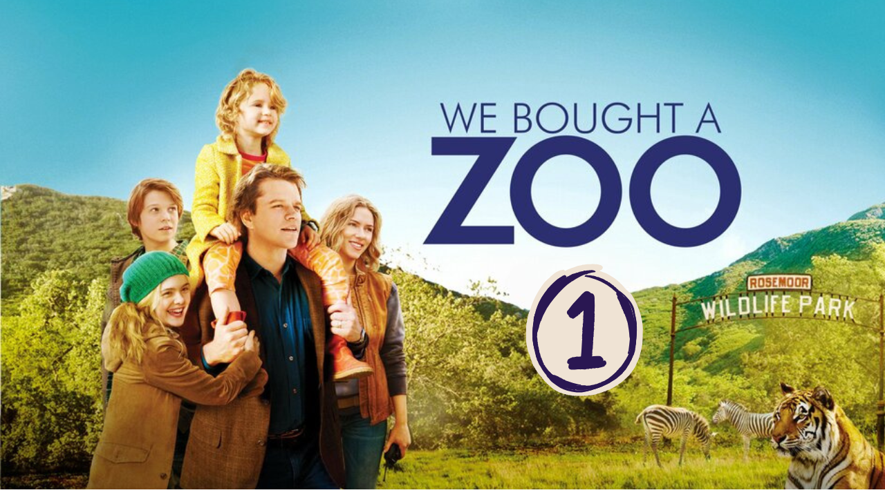
“We Bought a ZOO” (Scene 01)

Movie background

- Movie Background: Do your research to have an idea about the movie in terms of:
- Date: December 23, 2011
- Place: The story is set in Southern California (though it was filmed in various locations in California, including Thousand Oaks).
- Main Characters:
Benjamin Mee (played by Matt Damon) – A widowed father who buys a rundown zoo to start fresh with his family.

Kelly Foster (played by Scarlett Johansson) – The head zookeeper who helps Benjamin and his family restore the zoo.

Rosie Mee (played by Maggie Elizabeth Jones) – Benjamin’s young daughter.

Dylan Mee (played by Colin Ford) – Benjamin’s teenage son who struggles with the family’s big move.

Walter Ferris (played by John Michael Higgins) – A strict zoo inspector.

Peter MacCready (played by Angus Macfadyen) – A dedicated zoo staff member.

Part 01 / Work on the Scene

- Scene summary:

“The scene begins at Mr. Mee's home, where he is rushing to prepare breakfast for his children. After breakfast, he drives them to school. On the road, he challenges them to give him new words. When they arrive at school, he says goodbye to them and wishes them a good day. At the end of the scene, he talks with his brother, who encourages him to start a new life.”

- Scene Discussion & Analysis:

- Q01: What does Benjamin Mee do for a living?
... ... .... ... ... .... ... ... .... ... ... .... ... ... .... ... ... ....
- Q02: What does he look like?
... ... .... ... ... .... ... ... .... ... ... .... ... ... .... ... ... ....
- Q03: What is he like? (first impression)
He is a handsome blond middle-aged man. He is medium height, slim. He has short blond hair and green eyes.
- Q04: Is he married?
He is a widower.
- Q05: How many children does he have?
He has two children.
- Q06: What do they look like?
Dylan is a handsome young boy. He is medium height and slim. He has short blond hair and green eyes. Rosie is a beautiful little girl. She is short and slim. She has long street blond hair and green eyes.
- Q07: Does his brother look younger than him?
No, he donesn’t.
- Q08: Does his brother seem supportive?
No, he doesn’t.
- Q09: What was his brother’s advice?
He advices him to start a new life.

Part 02 / Acquired vocabulary & Grammar from the scene

- Acquired Vocabulary (OPTIONAL):

- Pernicious (adj):harmful, destructive, or causing serious damage, often in a subtle or gradual way.
- Example in a sentence:
“ Smoking has a pernicious effect on health.”
- The ins and outs:all the details, the complexities, or the full knowledge of something.
- Example in a sentence:
“ He knows the ins and the outs of the town.”
- To let some sunshine in (metaphor)to bring positivity, hope, or happiness into a situation; to brighten one’s life or mood.
- Example in a sentence:
“ I always try to let some sunshine into my daily life."”

- Irregular Verbs:

Infinitive | Past simple | Past participle
To know | knew | known
To think | thought | thought
To get out | Got it | Gotten it
To let | let | let

- Grammar note form the SCENE:
*** Not included in SCENE 01 ***

Part 03/ TRANSCRIPTION: improve your listening (Optional)

Task: Transcribe sentences from the scene.

- Transcribe Sentence 01
- Look I am the one who gets the emails about your lucked offered man okay. You either know where the book is or you don’t.

- Transcribe Sentence 02
- It causing insidious harm or ruin, causing damage

- Transcribe Sentence 03
- Human interaction is a good thing take it from my guys have been six months from a commercial fishing boat in Baly trying to find them self …

Open discussion
\
Not included in SCENE 01

Additional Notes (if any)

.... .... .... .... .... .... ..... .... .... .... .... .... ..... .... .... .... .... .... ..... .... .... .... .... .... ..... .... .... .... .... .... ..... .... .... .... .... .... ..... .... .... .... .... .... ..... .... .... .... .... .... ..... .... .... .... .... .... ..... .... .... .... .... .... ..... .... .... .... .... .... ..... .... .... .... .... .... ..... .... .... .... .... .... ..... .... .... .... .... .... ..... .... .... .... .... .... ..... .... .... .... .... .... ..... .... .... .... .... .... ..... .... .... .... .... .... ..... .... .... .... .... .... ..... .... .... .... .... .... ..... .... .... .... .... .... ..... .... .... .... .... .... ..... .... .... .... .... .... ..... .... .... .... .... .... ..... .... .... .... .... .... ..... .... .... .... .... .... ..... .... .... .... .... .... ..... .... .... .... .... .... ..... .... .... .... .... .... ..... .... .... .... .... .... ..... .... .... .... .... .... .....

